**VBA Lab**

In this lab, you are being asked to create a financial tracking application for a small business using MS Excel. This lab requires a conversation with Professor Enke regarding the development and implementation of your system. In addition, the system requirements for the system must be discussed and approved with Professor Enke. The minimum requirements for the system are as follows:

1. Your application must have an end-user form
2. Your application must store incoming and outgoing checks and the data regarding these transactions
3. Your application must store each transaction and reconcile the incoming and outgoing expenditures and provide a total

Demonstrate and discuss your lab solution with Professor Enke and upon approval submit all the files you have created via BlackBoard.

Define:

Small Richard and Friends is a quaint donut business off Main Street in the completely real town of Fitzburg (A town renown for its physical prowess and hopelessly small legs). The owner, Paul, is reaching out to have me make him a financial tracker to record the transactions of the failing company. I am required to record the incoming and outgoing checks and the data regarding these transactions (Not including state or federal taxes, this is only to track the buying and selling of goods). Paul has a specific rule that everything must be bought and sold via checks. On top of the recorded data, I am required to display a net total of the incoming and outgoing expenditures. Both Paul and his only employee; a dog named Bosco, know only how to use Microsoft Excel. Because Bosco has such a drinking problem; I will have to put minor validation and passwords on the project.

Requirements:

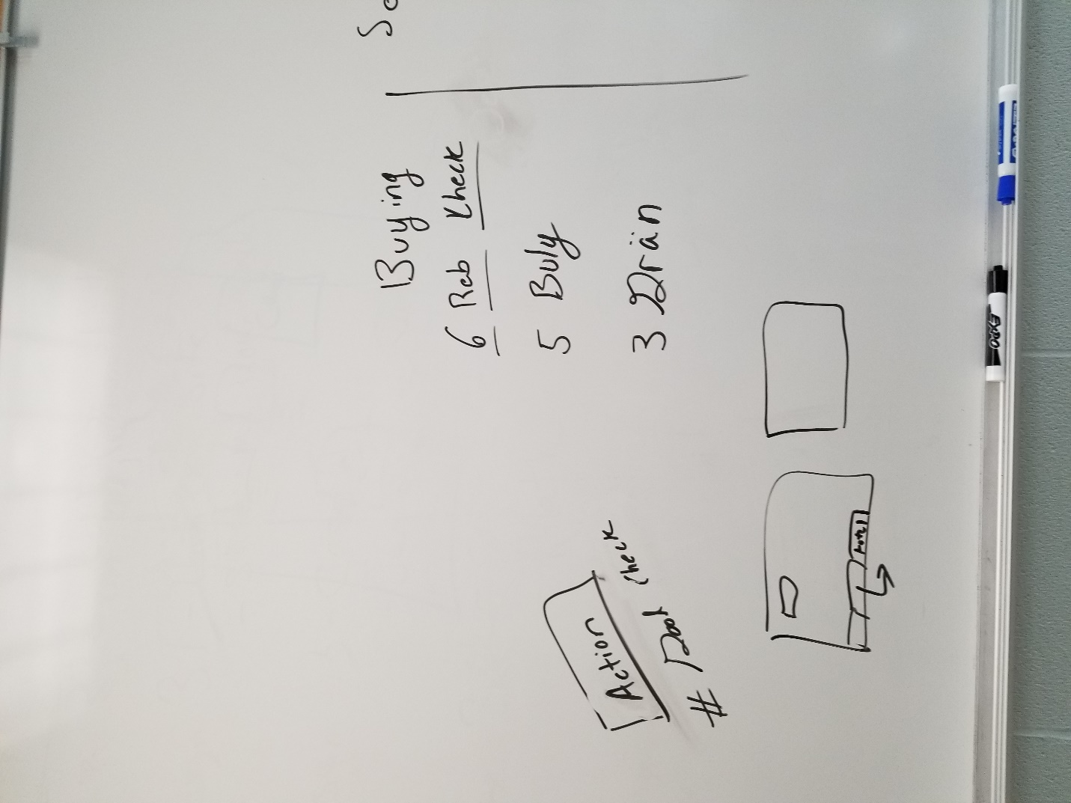

* Must have an interface – form of check for ease of use
  + To ease of use I will make the tab order from top to bottom
  + I will also add a brief description of each box so that it is easily understood
  + Main interface will be Sales and Purchase button with a total underneath and a button to calculate the total
* Store incoming and outgoing checks
  + Good sold
  + Data will be stored in the excel file in their respective tabs
  + 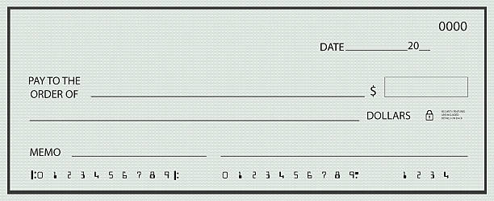Check information (information that is on a check see below)